Remember:

# Internetworking Tutorial 2

Addressing and Subnetting

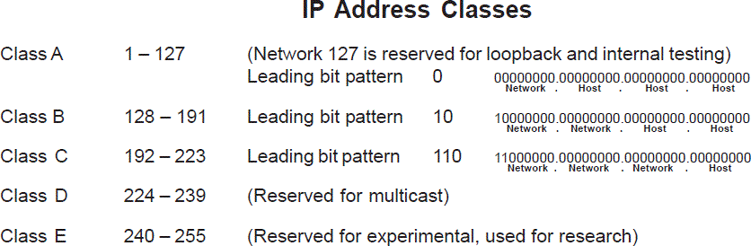

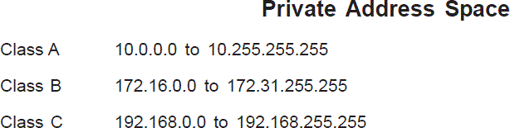

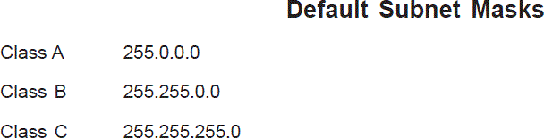

Convert of the following **8-bit binary** numbers to decimal by using the provided table. **Attempt as many as possible** **and refrain from using a calculator or a search engine**, simply practice!

|  |  |  |  |  |  |  |  |  |  |
| --- | --- | --- | --- | --- | --- | --- | --- | --- | --- |
| Binary Value | 128 = $2^{7}$ | 64= $2^{6}$ | 32= $2^{5}$ | 16= $2^{4}$ | 8= $2^{3}$ | 4= $2^{2}$ | 2= $2^{1}$ | 1= $2^{0}$ | Decimal Value |
| 00011011 | 0 | 0 | 0 | 1 | 1 | 0 | 1 | 1 | 27 |
| 10101010 | 1 | 0 | 1 | 0 | 1 | 0 | 1 | 0 | 170 |
| 01101111 | 0 | 1 | 1 | 0 | 1 | 1 | 1 | 1 | 111 |
| 11111000 | 1 | 1 | 1 | 1 | 1 | 0 | 0 | 0 | 248 |
| 00100000 | 0 | 0 | 1 | 0 | 0 | 0 | 0 | 0 | 32 |
| 01010101 | 0 | 1 | 0 | 1 | 0 | 1 | 0 | 1 | 85 |
| 00111110 | 0 | 0 | 1 | 1 | 1 | 1 | 1 | 0 | 62 |
| 00000011 | 0 | 0 | 0 | 0 | 0 | 0 | 1 | 1 | 3 |
| 11101101 | 1 | 1 | 1 | 0 | 1 | 1 | 0 | 1 | 237 |
| 11000000 | 1 | 1 | 0 | 0 | 0 | 0 | 0 | 0 | 192 |

# Exercise 2:

Convert the following decimal numbers to **8-bit binary numbers** and complete the provided table. **Attempt as many as possible and refrain from using a calculator or a search engine**.

|  |  |  |  |  |  |  |  |  |
| --- | --- | --- | --- | --- | --- | --- | --- | --- |
| Decimal  Value | 128 | 64 | 32 | 16 | 8 | 4 | 2 | 1 |
| 255 | 1 | 1 | 1 | 1 | 1 | 1 | 1 | 1 |
| 192 | 1 | 1 | 0 | 0 | 0 | 0 | 0 | 0 |
| 172 | 1 | 0 | 1 | 0 | 1 | 1 | 0 | 0 |
| 256 | Can’t | Represent | With | Only | Eight | Bits | Of | Binary |
| 1 | 0 | 0 | 0 | 0 | 0 | 0 | 0 | 1 |
| 13 | 0 | 0 | 0 | 0 | 1 | 1 | 0 | 1 |
| 204 | 1 | 1 | 0 | 0 | 1 | 1 | 0 | 0 |
| 10 | 0 | 0 | 0 | 0 | 1 | 0 | 1 | 0 |
| 98 | 0 | 1 | 1 | 0 | 0 | 0 | 1 | 0 |
| 179 | 1 | 0 | 1 | 1 | 0 | 0 | 1 | 1 |
| 224 | 1 | 1 | 1 | 0 | 0 | 0 | 0 | 0 |
| 239 | 1 | 1 | 1 | 0 | 1 | 1 | 1 | 1 |
|  |  |  |  |  |  |  |  |  |

Identify the Class the following IP addresses belong to. **Attempt as many as possible. Advise the information on page 1.**

|  |  |
| --- | --- |
| IP Address | Class |
| 10.250.1.1 | A |
| 150.10.15.0 | B |
| 1492.14.2.0 | ? |
| 148.17.9.1 | B |
| 193.42.1.1 | C |
| 126.8.156.4 | B |
| 220.200.24.1 | C |
| 231.230.46.58 | D |
| 177.100.18.4 | B |
| 119.18.46.9 | A |
| 249.240.82.79 | E |
| 199.156.76.57 | C |
| 10.256.2.3 | ? |
| 95.0.21.90 | A |

# Exercise 4:

Identify the network and host portions for the following IP addresses. **Attempt as many as possible. Advise the information on page 1**.

|  |  |  |
| --- | --- | --- |
| IP Address | Network address (network ID) | Host address (host ID) |
| 10.250.1.1 | 10.0.0.0 | 0.250.1.1 |
| 150.10.15.0 | 150.10.0.0 | 0.0.15.0 |
| 1492.14.2.0 | ? |  |
| 148.17.9.1 | 148.17.0.0 | 0.0.9.1 |
| 193.42.1.1 | 193.42.1.0 | 0.0.0.1 |
| 126.8.156.4 | 126.0.0.0 | 0.8.156.4 |
| 220.200.24.1 | 220.200.24.0 | 0.0.0.1 |
| 231.230.46.58 | D |  |
| 177.100.18.4 | 177.100.0.0 | 0.0.18.4 |
| 119.18.46.9 | 119.0.0.0 | 0.18.46.9 |
| 249.240.82.79 | E |  |
| 199.156.76.57 | 199.156.76.0 | 0.0.0.57 |
| 10.256.2.3 | ? |  |
| 95.0.21.90 | 95.0.0.0 | 0.0.21.90 |
|  |  |  |

Calculate the network address and host address for the following IP addresses as defined by the provided custom subnet mask.

For example:

156.222.32.27 / 255.255.255.0 ➔ 156.222.32.0 (network) and 0.0.0.27 (host)

|  |  |  |
| --- | --- | --- |
| IP Address / Subnet mask | Network Address (Network  ID) | Host Address (Host ID) |
| 188.11.18.3 / 255.255.0.0 | 188.11.0.0 | 0.0.18.3 |
| 10.11.48.81 / 255.255.255.0 | 10.11.48.0 | 0.0.0.81 |
| 192.168.23.185 / 255.255.255.0 | 192.168.23.0 | 0.0.0.185 |
| 150.203.23.19 / 255.255.0.0 | 150.203.0.0 | 0.0.23.19 |
| 10.11.12.13 / 255.0.0.0 | 10.0.0.0 | 0.11.12.13 |
| 186.14.25.114 / 255.255.255.0 | 186.14.25.0 | 0.0.0.114 |
| 199.21.201.152 / 255.0.0.0 | 199.0.0.0 | 0.21.201.152 |
| 191.55.168.123 / 255.255.255.0 | 191.55.168.0 | 0.0.0.123 |
| 28.252.250.254 / 255.255.0.0 | 28.252.0.0 | 0.0.250.254 |
| 192.168.254.254 / 255.255.0.0 | 192.168.0.0 | 0.0.254.254 |
| 10.1.5.254 / 255.255.255.0 | 10.1.5.0 | 0.0.0.254 |

# Exercise 6:

For the following IP address and the provided subnet mask calculate the number of subnets and hosts you have for each subnet.

Scenario 1 - Default subnet mask IP address: 192.100.10.0

Default subnet mask: 255.255.255.0

Number of subnets = 1

Number of hosts per subnet = 254

Scenario 2 – Custom subnet mask IP address: 192.100.10.0

Custom Subnet mask: 255.255.255.240 Number of subnets = 16

Number of hosts per subnet = 14